Linux Permission Commands

1. **Cat> :** used to create a file with any content

1. **Touch :** used to create a file without any content



1. **What is :** Command used in describing the other command’s functions.

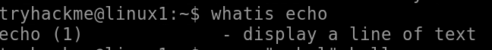

1. **Cd :** used to change the working directory of the working drive or another lettered drive.

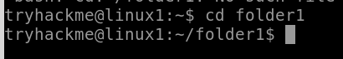

1. **Pwd :** command prints the full name (the full path) of current/working directory



# **WC (Word Count) :** shown the word count as well as the number of bytes, words, and lines in files

1. **ls -l :** This displays a long listing with detailed information

# **Chmod :** used to change the access permissions of files and directories .

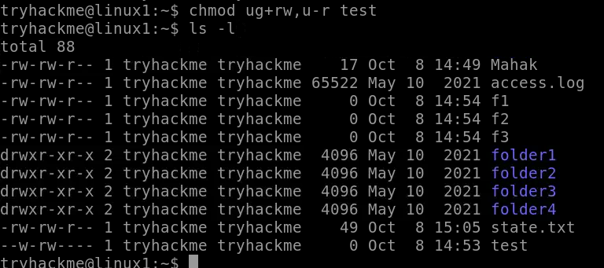

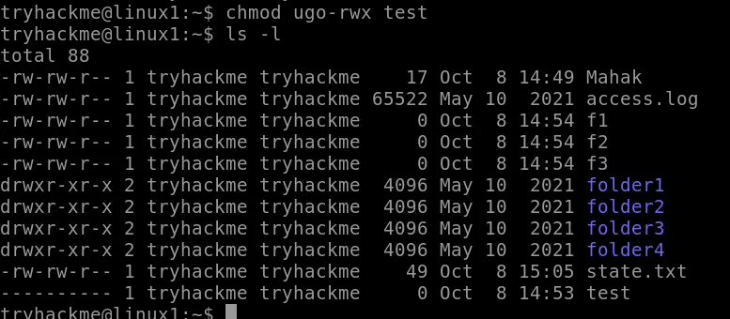

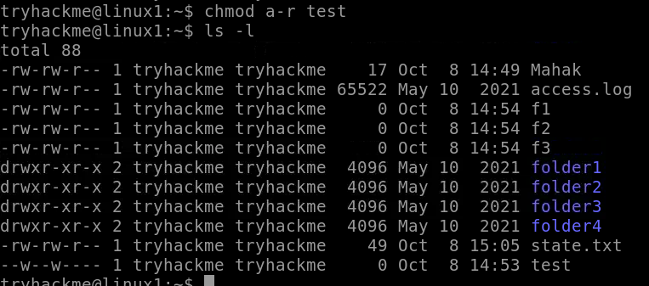

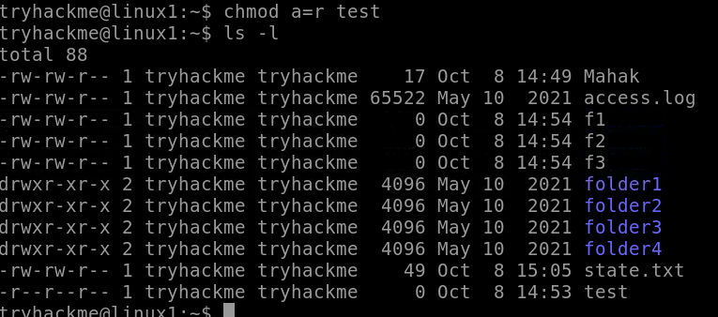

**9. Grep** : used in searching and matching text files contained in the regular expressions



**10. Find:** find helps you find things, and not just by filename

 

**11. Man find :** used to display the user manual of any command that we can run on the terminal

